Week 2 Project Log Template – Data Analytics (TXT)
PROJECT LOG – WEEK 2 (DATA ANALYTICS)
Student Name(s): ______________________________
Student ID(s): ______________________________
Project Title: _ Browser Security Evaluation and Hardening: A Comparative Study of Chrome, Firefox, and Edge_____________________________
Supervisor: ______________________________
Week: ___2_______
Git Repository URL: ____ https://github.com/TestMyServer/BrowserSecurityEvaluation

Summary of Work Completed
- Imported project datasets into the analytics environment.
- Planned and initiated data cleaning procedures (missing values, duplicates, type consistency).
- Performed initial ETL staging: extraction and preliminary transformations.
- Conducted exploratory data analysis (EDA) to understand distributions, correlations, and data quality.
- Documented observations for further analysis and validation.

2. Evidence of Technical Progress
- The screenshot are highlighted as below:
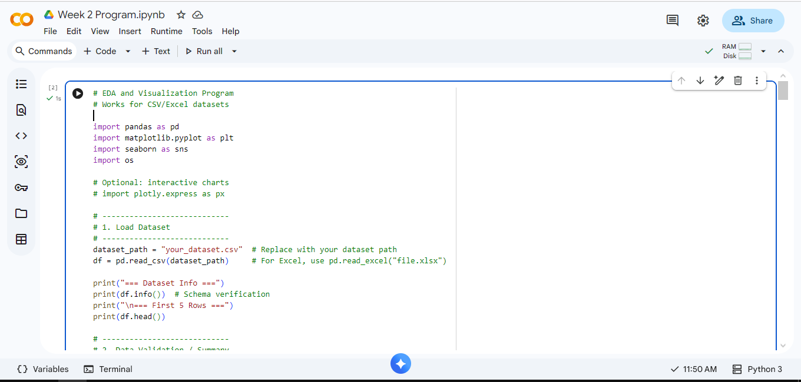
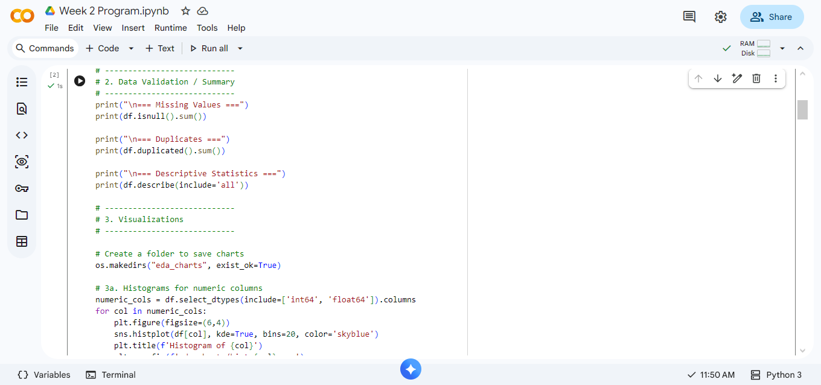
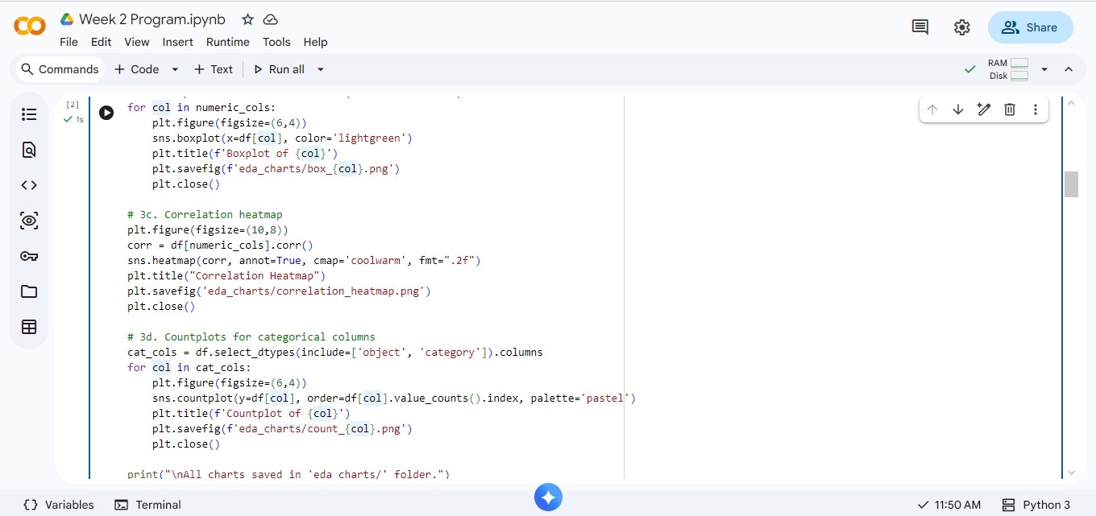
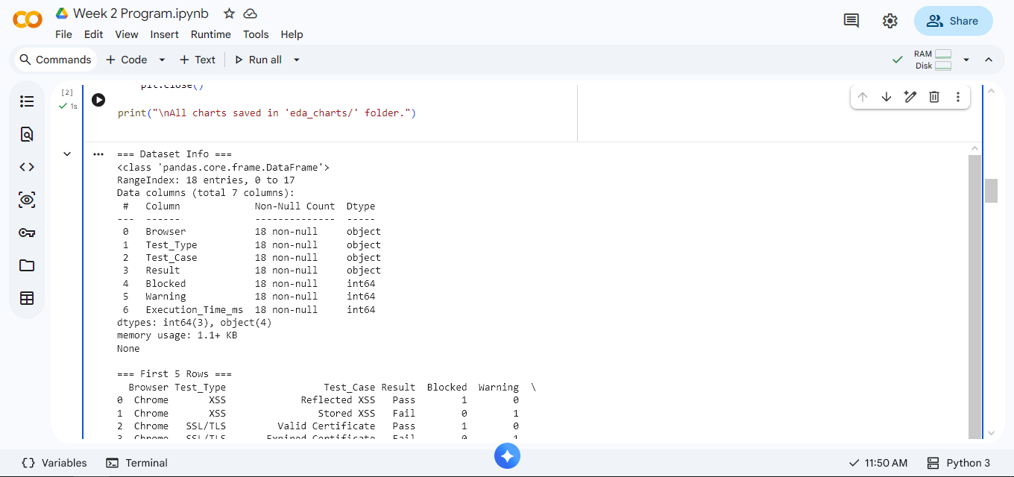

3. Data Ingestion Notes
- Imported datasets: list all relevant files/tables.
- Issues found: e.g., inconsistent formatting, missing headers, encoding errors.
- Data validation comments: checked column types, key constraints, value ranges.

4. Cleaning Plan Summary
- Missing values handling: imputation or removal strategies.
- Duplicates: identification and removal approach.
- Data types: conversion to appropriate types (numeric, categorical, datetime).
- Outliers: detection and plan for treatment.
- Formatting: standardization of dates, text fields, and categorical labels.

5. ETL Staging Details
- Extract: imported raw datasets from source files or databases.
- Transform: applied cleaning, type conversions, computed new fields if required.
- Load: staged cleaned data into target data structures or temporary tables for analysis.

6. Initial EDA Findings
- Distribution of key variables (e.g., normal, skewed).
- Correlation analysis highlighting strong/weak relationships.
- Data quality insights: missing patterns, anomalies, inconsistencies.

7. Issues / Risks
- Missing or incomplete data affecting analysis reliability.
- Duplicates or inconsistent formatting in critical fields.
- ETL script errors or performance issues.
- Potential misinterpretation of data patterns without further validation.

8. Plan for Week 3
- Finalize data cleaning and ETL staging.
- Conduct in-depth EDA with visualization dashboards.
- Generate descriptive statistics and correlation matrices.
- Begin feature engineering and prepare dataset for modeling or analysis.
- Document all findings and scripts in Git repository.

